Functional Specification
Import Promotion functional specification covering the overview, inputs, outputs, activity flow, and screen/process flow.

Import Promotion

Overview
Purpose: Convert validated imported rows into permanent transactions.
Scope: Review eligible rows, confirm promotion, validate references, create transactions, update balances, and display results.

Input
- Selected import batch containing validated, unpromoted rows.
- Resolved active account and category references for each eligible row.
- Transaction details, including amount, transaction date, type, and duplicate status.
- User confirmation to start promotion.

Output
- Permanent transactions created for successfully promoted rows.
- Updated account balances for successful transactions.
- Unpromoted rows retained with clear skip or failure reasons.
- Promotion summary showing promoted, skipped, and failed totals.

Activity Diagram
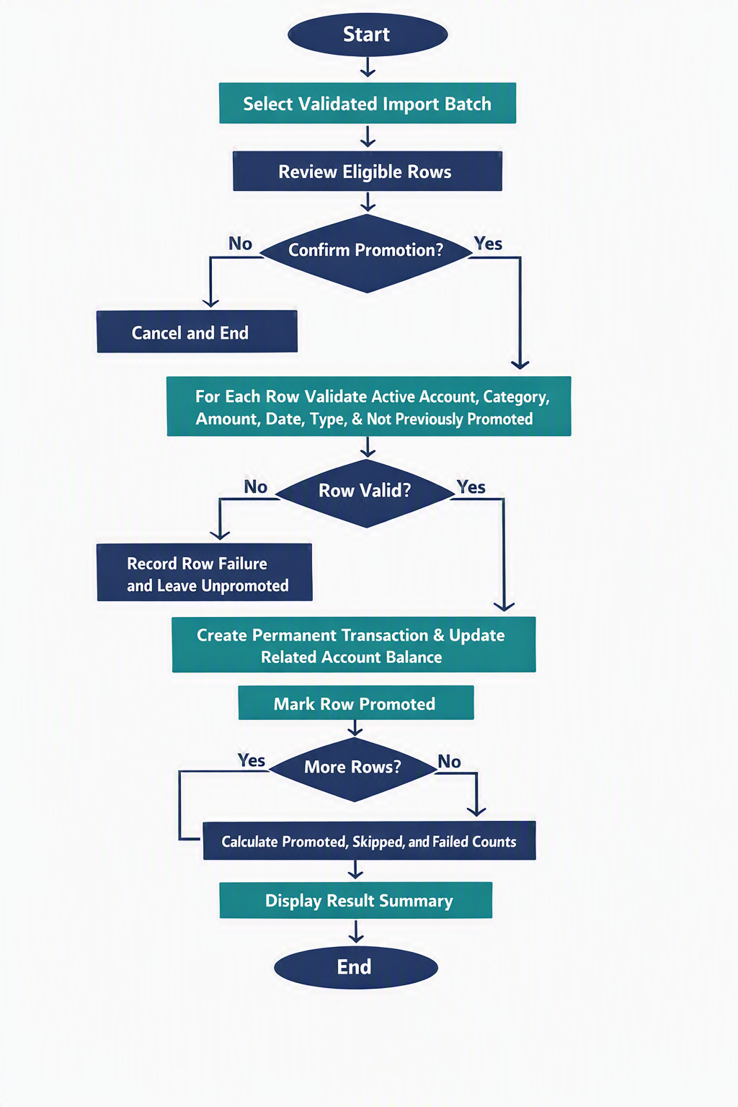

Figure 3 — Import Promotion activity diagram.

Screen and Process Flow
- User selects a validated batch and reviews eligible rows.
- User confirms promotion.
- System validates account, category, amount, date, type, and duplicate status.
- Valid rows create transactions and update balances; invalid rows retain failure reasons.
- System displays promoted, skipped, and failed totals.
Positive Test: Valid rows are promoted once and balances are updated.
Negative Test: Inactive references fail without balance changes.
Boundary Test: Repeated promotion creates no duplicates.

